**Validation of the user login**

**Screenshot**

**web.xml**

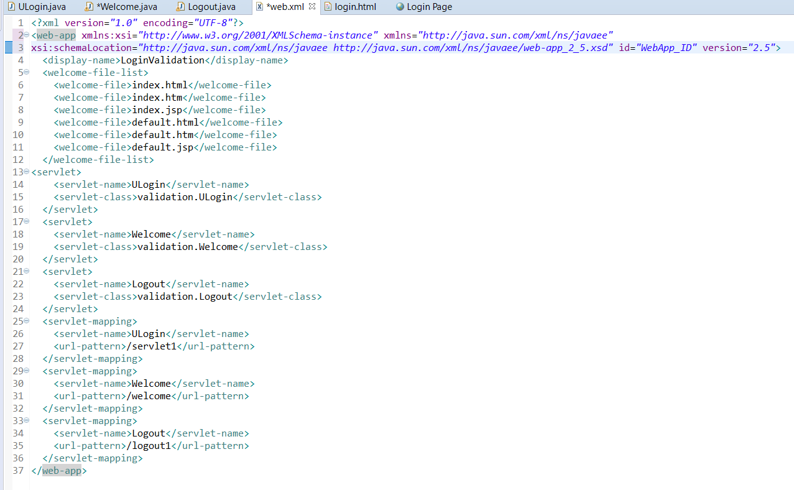

**Login.html**

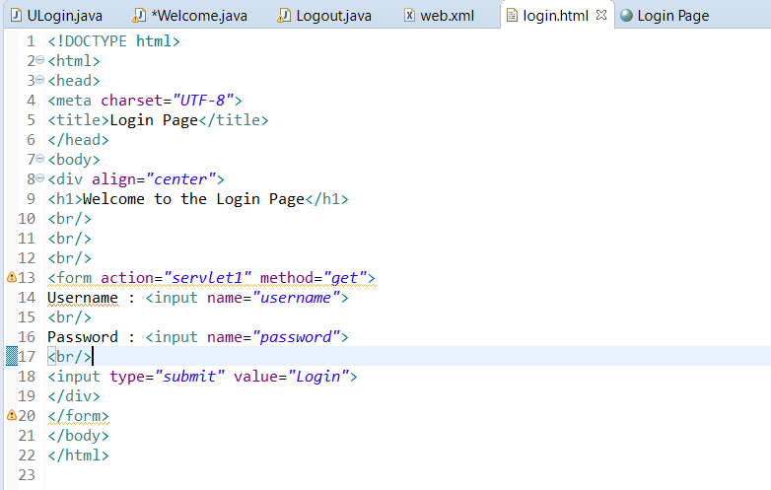

**Welcome.java**

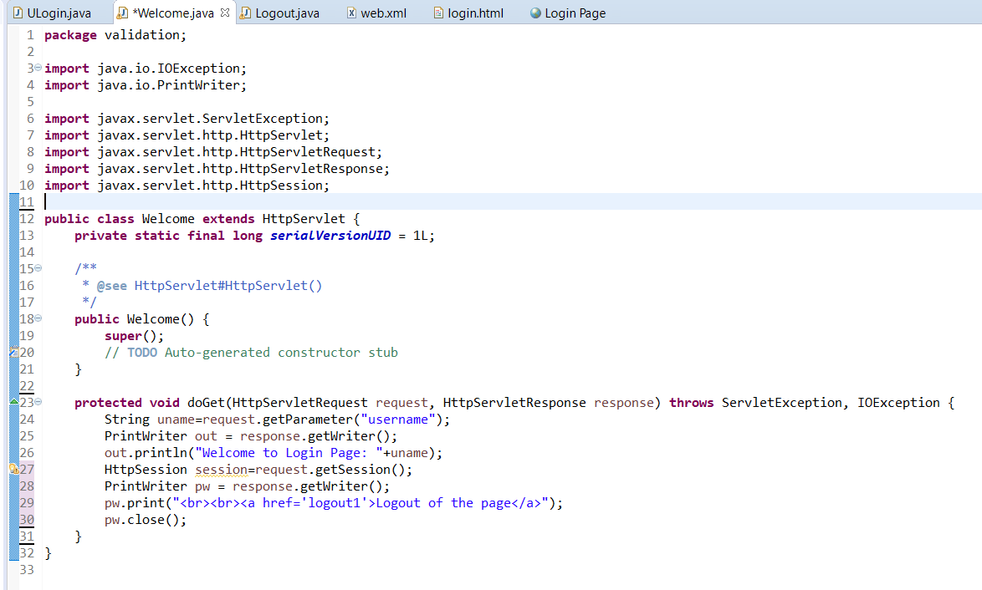

**ULogin.java**

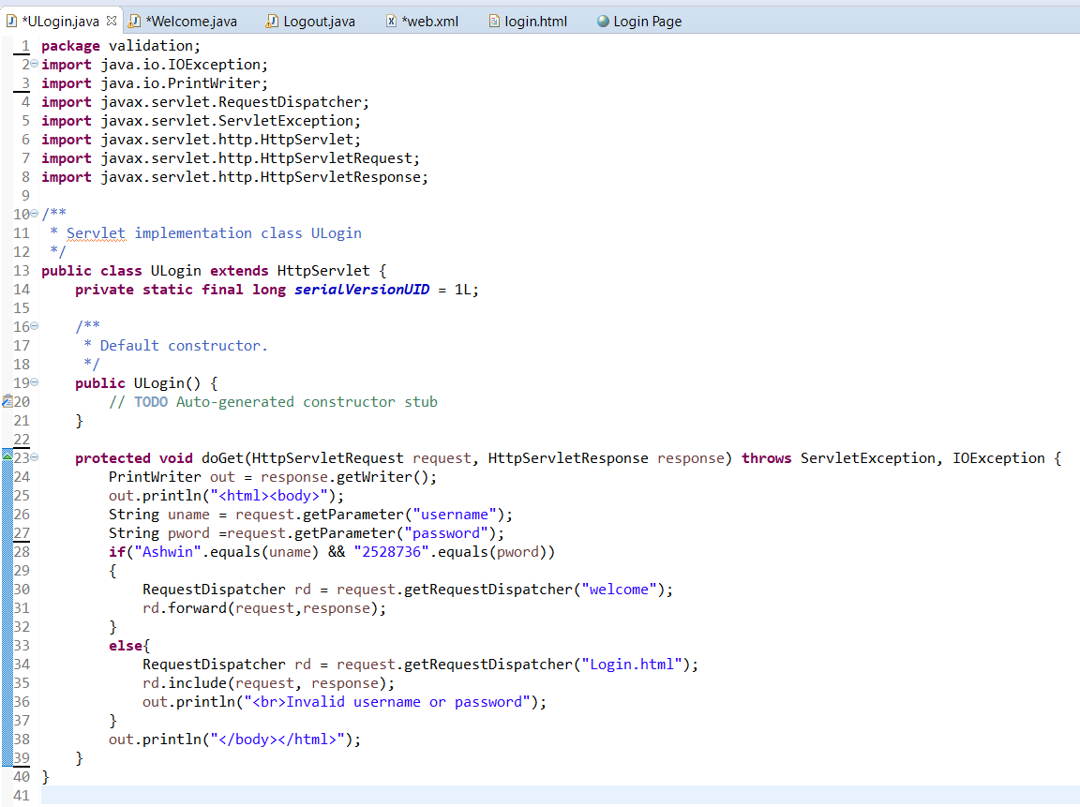

**Logout.java**

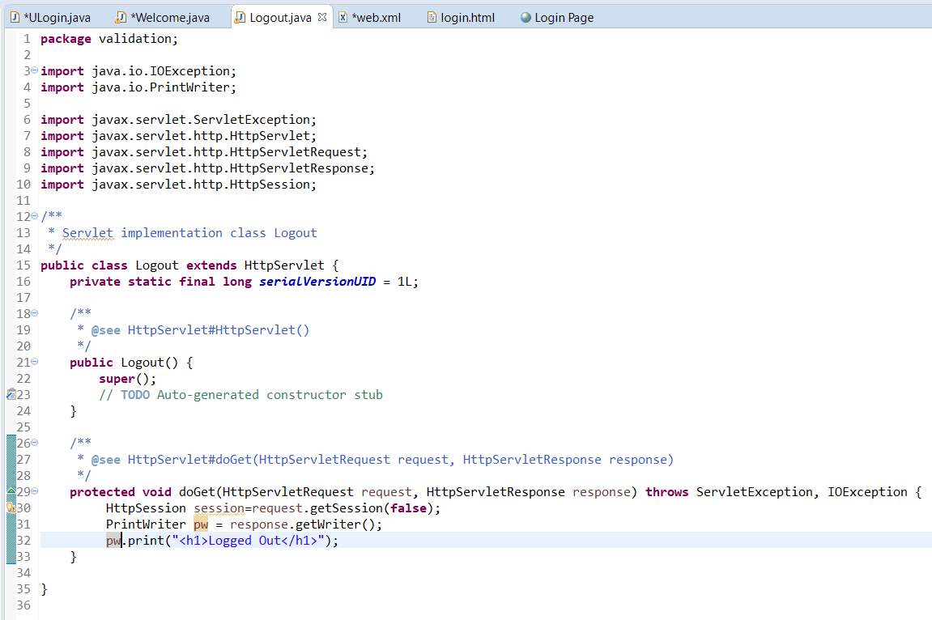

**OUTPUT**

